SOLUBILITY CURVES Name: __________________________
Answer the following questions based on the solubility curve below.
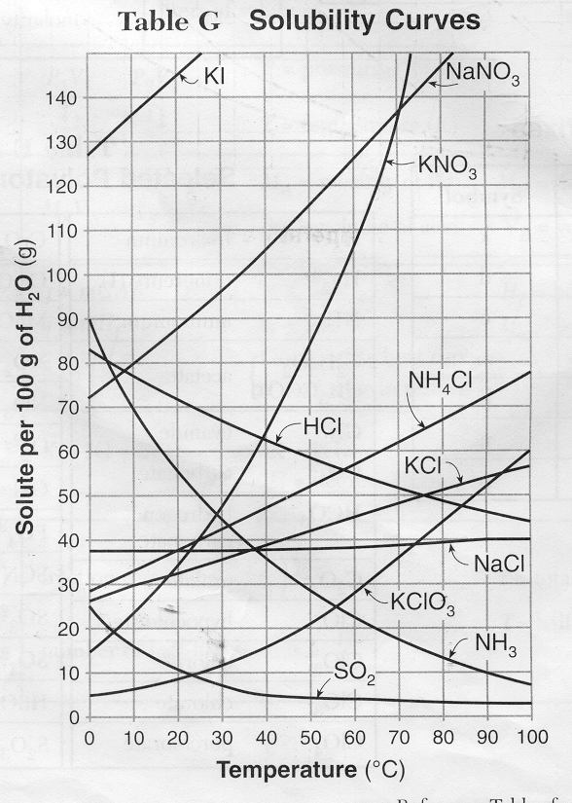
- Which salt is least soluble in water at 20 °C?
- How many grams of potassium chloride can be dissolved in 200 g of water at 80 °C?
- At 40 °C, how much potassium nitrate can be dissolved in 300 g of water?
- Which salt shows the least change in solubility from 0 °- l00 °C?
- At 30 °C, 90 g of sodium nitrate is dissolved in 100 g of water. Is this solution saturated, unsaturated or supersaturated?
- A saturated solution of potassium chlorate is formed from one hundred grams of water. If the saturated solution is cooled from 80 °C to 50 °C, how many grams of precipitate are formed?
- What compounds show a decrease in solubility from 0 ° to 100 °C?
- Which salt is most soluble at 10 °C?
- Which salt is least soluble at 50 °C?
- Which salt is least soluble at 90 °C?

